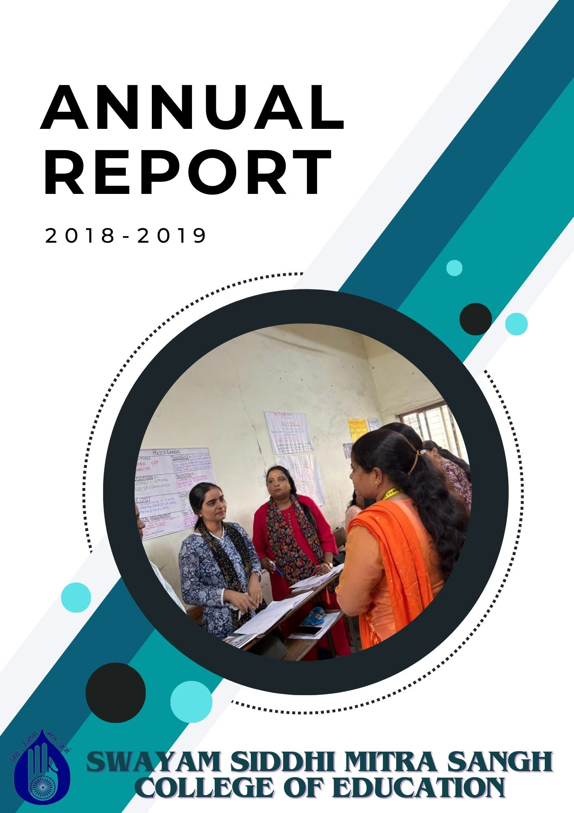

Swayam Siddhi Mitra Sangh College of Education was established in 2004, is the outcome of the sincere and dedicatory efforts of the Trust member under the bold charismatic leadership of CA Shri Suresh Jain and Shri Parag Khandekar. Their vision and love for women empowerment and education made them work hard with the co-operation of the local residents towards the establishment of this college . The college is recognized by the NCTE and affiliated by the SNDT WOMEN’S UNIVERSITY. The College is located in Bhiwandi District Thane Maharashtra state. It reflects the sincerity and devotion of the Teachers towards the institute and commitment of the welfare of education, specially teacher education. The Trust also run the esteemed school by the name of SWAYAM SIDDHI GURUKUL SCHOOL ,which is affiliated to State board. Demographically, this locality is dominated by local agris and kolis, Muslim and migrated population from south and North To be a leader in Educational services Institute provides a Unique learning Experience which enables the students to realize their potential and mould their overall Personality. It also make available equal opportunities and ensure support without prejudice based on class, caste, religion and economic status.

**Our Vision**

Building a generation of excellent empowered teachers with higher values.

This is achieved by following way

* Use Language that Empowers Teachers. The way we talk to and about teachers makes a big difference in how they feel about themselves and their work
* Provide Frequent, Specific Feedback.
* Encourage Teacher Leadership.
* Support Teacher Professional Development.
* Promote a Positive institutional Culture

MISSION

* To strengthen the weaker sections of Maharashtra state through higher education.
* To empower student teachers by educating them and by creating in them the social, political and cultural awareness.
* To build student teachers confidence to be nation builders. Striving continuously to Provide quality teacher training.
* To carry out teaching and training programs for aspirants as per the norms and standards set by NCTE and state govt.
* To effectively execute various activities under the academic and social responsibility,

**Infrastructure and Learning Resources**

Infrastructure and Learning Resources The college has adequate infrastructure facilities and resources as per NCTE Norms. The college has built up area of more than 3000.00 sq. m, that consists of Multipurpose Hall, Classrooms, Sports Room , Staff Room, Girl’s Common Room, Canteen, Library-Cum-Reading Room, Laboratories, Principal’s Office, Administrative Office, Store Room, multipurpose hall and play ground. The library is Wi-Fi enabled and well equipped with all the facilities for students and staff members . It consists of wide varieties of text books, reference books of various subjects, magazine and journals. The College puts forth extraordinary attempts to give the furthest down the line innovation to understudies, staying up with the latest with the global world. ICT facilities are accessible to students and staff for exercises connected with instructing educational experience. Throughout the long term college upgrades its equipment, programming and united ICT facilities as indicated by necessities. They also use various ICT resources such as Google and Zoom platform and providing variety of learning experiences to the students. In order to train them in 21st century skills student teachers are encouraged to participate in various activities to gain real life experiences during their internship so that pedagogical skills are developed in them.

B.Ed course is a professional degree course . In this course number of activities are included for the development of the professional skill of the students. To fulfil professional objectives our college organised many activities in the year 2018-2019.The activity Programme included skill development program, orientation program sports ,various day celebration, field trip NGO community work etc

**Skill development programme**

We trained our students to learn all the required teaching skill necessary for the teaching profession. We helped them to get deeper knowledge regarding the art of teaching. For that the students were trained for different skills such as set induction skill or introduction skill in that they learned how to introduce subject topic while teaching in class room, they also learned how to probe questions by questioning skill, other skills were explanation skill and demonstration skill etc

|  |  |
| --- | --- |
|  |  |

**Orientation programme**

The goal of the orientation programme is to equip the student with the necessary requirement of the activities in the teaching profession . To achieve these objectives our professors were guided our students at each and every step throughout the whole academic year of 2018-2019. Orientation was taken during the whole academy year for various activities such as skill development programme, for assignment writing, before starting the internship program etc.

|  |  |
| --- | --- |
|  |  |

**Annual sports**

Annual sports day was held on 5/2/2018-7/2/2018 at the campus of Swayam Siddhi Mitra Sangh college. There was both indoor and outdoor games. We took carrom and chess for indoor game. In outdoor games we took dodgeball, kho kho ,badminton running etc. Student teacher not only participated as competitors but also learnt how to plan and organised such events in school.

|  |  |
| --- | --- |
|  |  |

**Day celebration**

Different programmes where planed and organised by the college to inform the student teacher about the cultural importance of special days celebration in school,and also the importance of national integration. Student were participated in those activities. Following are the days which were celebrated during the year 2018-2019.

|  |  |
| --- | --- |
| **Days** | **Date** |
| Navratri day | 14 Oct |
| World student day | 15 Oct |
| Reading day | 14 Oct |
| Constitutional day | 26 Nov |
| Diwali | 7 Nov |
| Children’s day | 14 Nov |
| AID’s Day | 1 Dec |

|  |  |
| --- | --- |
|  |  |

**Field trips**

Field trips play crucial role in the student learning process. Through field trip student teacher can strengthen their creativity, problem solving skills and critical thinking.The students of S.Y. B.Ed and faculty members had a field visit to Nashik on 8 June 2018. The visit was planned so that the student teacher could learn how to stimulate the senses of the pupils, also they learned to motivate curiosity among the pupils.

Sports were

* Botanical Garden
* Caves
* Planetarium
* Coin Museum
* WaterFall

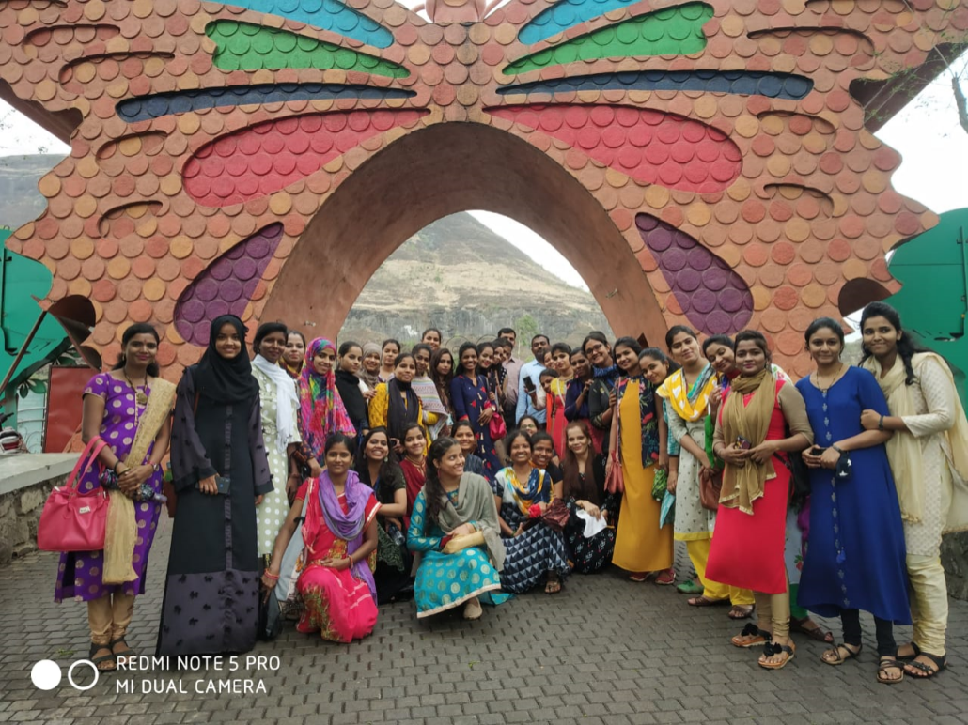

**Community work**

**Visit to NGO**

NGO raises awareness about issues such as human rights ,violations environmental conservation, public health, poverty and more it is necessary for the B.Ed students to gain knowledge about those things. Students were visited at varius NGOs in that year.