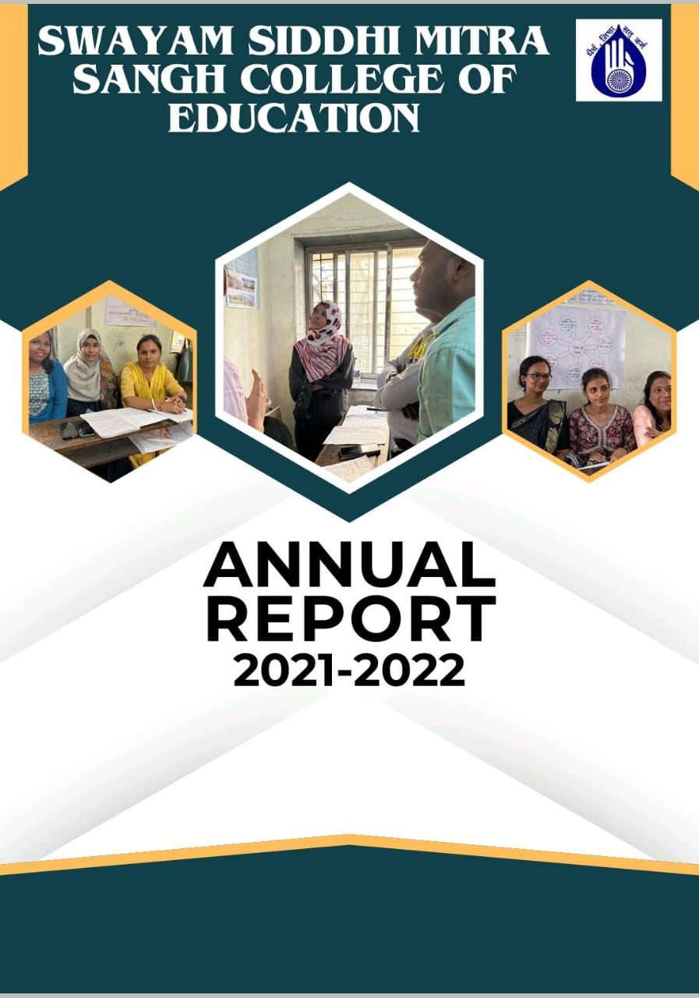

Swayam Siddhi Mitra Sangh College of Education was established in 2004, is the outcome of the sincere and dedicatory efforts of the Trust member under the bold charismatic leadership of CA Shri Suresh Jain and Shri Parag Khandekar. Their vision and love for women empowerment and education made them work hard with the co-operation of the local residents towards the establishment of this college . The college is recognized by the NCTE and affiliated by the SNDT WOMEN’S UNIVERSITY. The College is located in Bhiwandi District Thane Maharashtra state. It reflects the sincerity and devotion of the Teachers towards the institute and commitment of the welfare of education, specially teacher education. The Trust also run the esteemed school by the name of SWAYAM SIDDHI GURUKUL SCHOOL ,which is affiliated to State board. Demographically, this locality is dominated by local agris and kolis, Muslim and migrated population from south and North To be a leader in Educational services Institute provides a Unique learning Experience which enables the students to realize their potential and mould their overall Personality. It also make available equal opportunities and ensure support without prejudice based on class, caste, religion and economic status.

**Our Vision**

Building a generation of excellent empowered teachers with higher values.

This is achieved by following way

* Use Language that Empowers Teachers. The way we talk to and about teachers makes a big difference in how they feel about themselves and their work
* Provide Frequent, Specific Feedback.
* Encourage Teacher Leadership.
* Support Teacher Professional Development.
* Promote a Positive institutional Culture

MISSION

* To strengthen the weaker sections of Maharashtra state through higher education.
* To empower student teachers by educating them and by creating in them the social, political and cultural awareness.
* To build student teachers confidence to be nation builders. Striving continuously to Provide quality teacher training.
* To carry out teaching and training programs for aspirants as per the norms and standards set by NCTE and state govt.
* To effectively execute various activities under the academic and social responsibility,

**Infrastructure and Learning Resources**

Infrastructure and Learning Resources The college has adequate infrastructure facilities and resources as per NCTE Norms. The college has built up area of more than 3000.00 sq. m, that consists of Multipurpose Hall, Classrooms, Sports Room , Staff Room, Girl’s Common Room, Canteen, Library-Cum-Reading Room, Laboratories, Principal’s Office, Administrative Office, Store Room, multipurpose hall and play ground. The library is Wi-Fi enabled and well equipped with all the facilities for students and staff members . It consists of wide varieties of text books, reference books of various subjects, magazine and journals. The College puts forth extraordinary attempts to give the furthest down the line innovation to understudies, staying up with the latest with the global world. ICT facilities are accessible to students and staff for exercises connected with instructing educational experience. Throughout the long term college upgrades its equipment, programming and united ICT facilities as indicated by necessities. They also use various ICT resources such as Google and Zoom platform and providing variety of learning experiences to the students. In order to train them in 21st century skills student teachers are encouraged to participate in various activities to gain real life experiences during their internship so that pedagogical skills are developed in them.

B.Ed course is a professional degree course . In this course number of activities are included for the development of the professional skill of the students. To fulfill professional objectives our college organized many activities in the year 2021-2022.The activity Programme included skill development program, orientation program sports ,various day celebration, field trip NGO community work etc

**Orientation Programme**

Orientation programmes are aimed at familiarizing the students to an unknown educational environment. It enables them to make essential connection with studies and develop network among different subjects. The goal of the orientation programme is to equip the student with the necessary requirement of the activities in the teaching profession. To achieve these objectives our professors were guided our students at each and every step throughout the whole academic year of 2021-2022. Orientation was taken during the whole academy year for various activities such as skill development programme, for assignment writing, before starting the internship program etc.

**Annual Sports**

Sports and games provide numerous benefits for students, such as physical fitness, improved mental health, better academic performance, improved self-esteem and social skills, and more. By getting involved in sports, students learn the importance of teamwork, hard work, and self-discipline. To achieve these objectives annual sports day was held on 17/12/2022-18/12/2022 at the campus of Swayam Siddhi Mitra Sangh college. There were both indoor and outdoor games. We took carom and chess for indoor game. In outdoor games we took dodge ball, khokho ,badminton running etc. Student teacher not only participated as competitors but also learnt how to plan and organized such events in school.

**Day celebration**

Day celebrations provide an opportunity to indulge in non-academic activities, to bond and break the ice with each other. It deepens the peer relationships and brings the students closer to the staff. To fulfill this objectives different programmes where planned and organized by the college to inform the student teacher about the cultural importance of special days celebration in school,and also the importance of national integration. Students were participated in those activities. In that year (2021-2022) student teachers celebrated Savitribai phule birth anniversary, reading day ,Diwli and Eid celebration etc.

**Community work**

**Visit to NGO**

.

NGO raises awareness about issues such as human rights ,violations environmental conservation, public health, poverty and more it is necessary for the B.Ed students to gain knowledge about those things. Students were visited at various NGOs in that year.

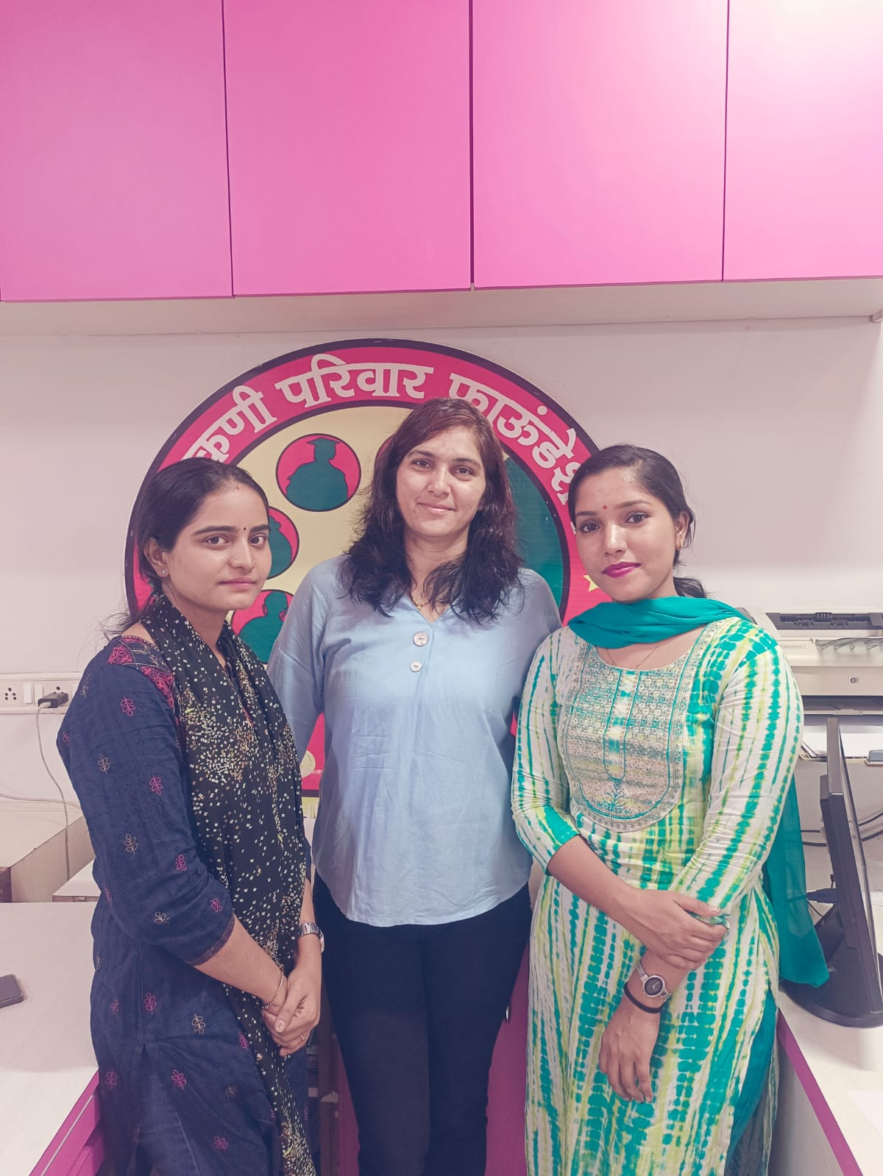

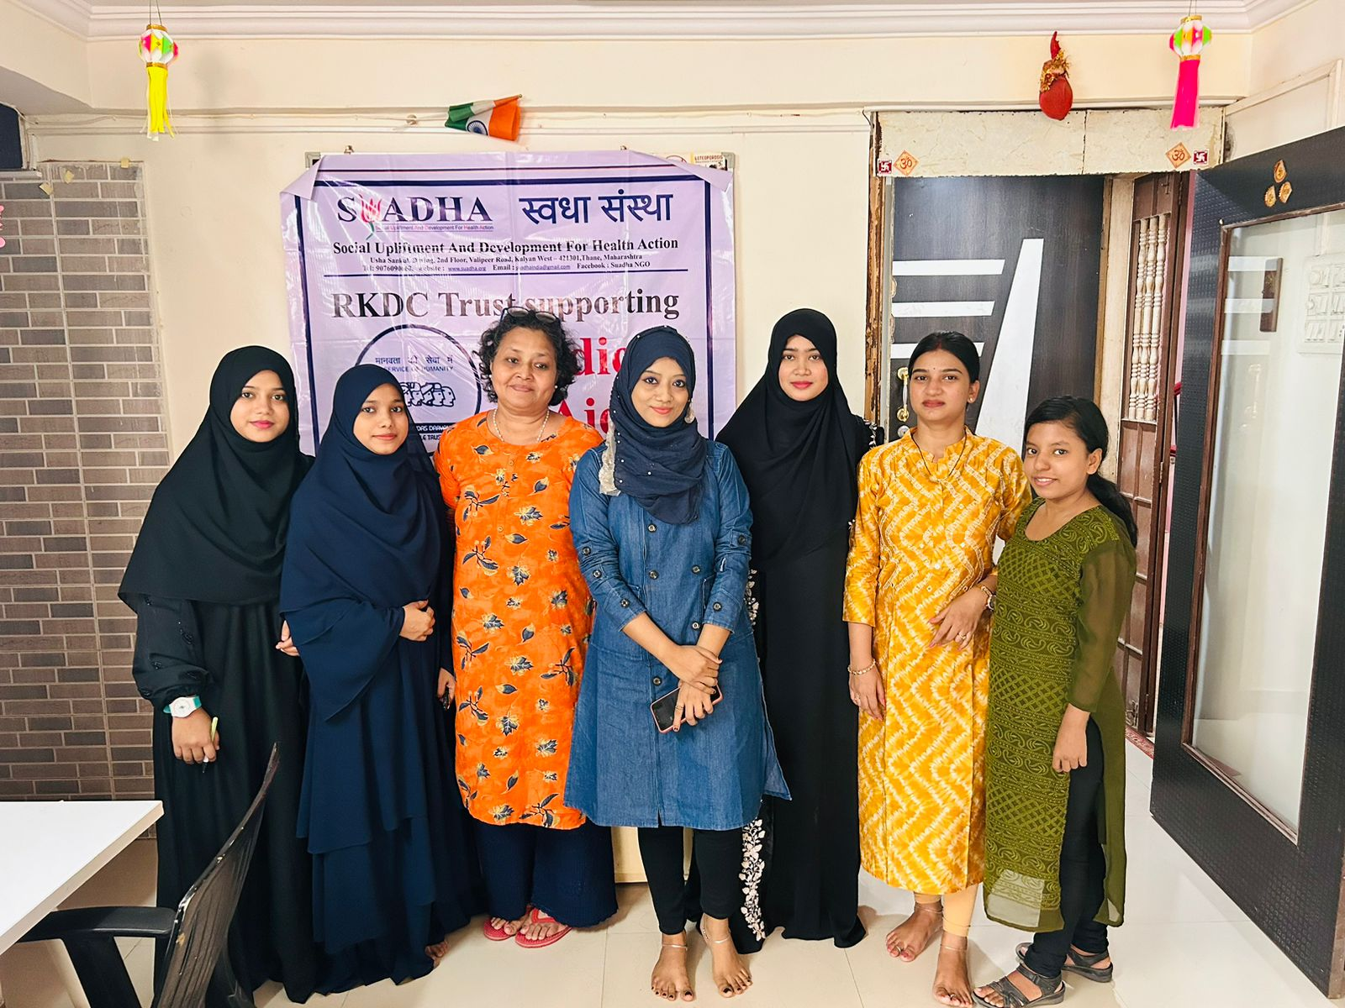

**Visit to Anatashram**

All the students of B.Ed visited at the Anatashram (Adharvad Charitable Trust) and spent their daytime with them shared their happiness. They also spent their pocket money in a useful manner by offering needy things to the . Children staying there.

