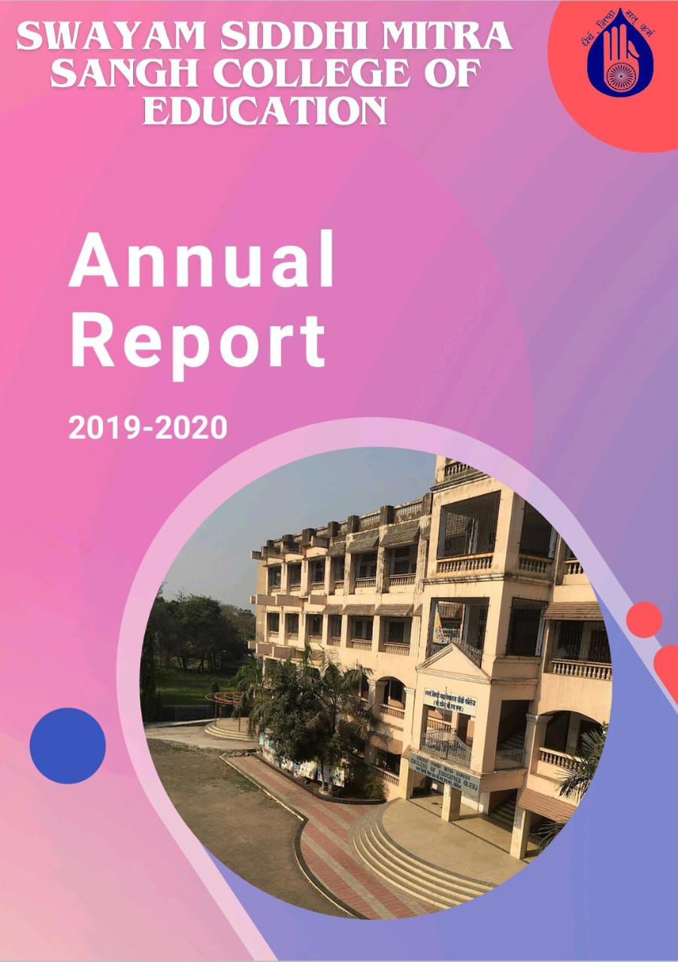

Swayam Siddhi Mitra Sangh College of Education was established in 2004, is the outcome of the sincere and dedicatory efforts of the Trust member under the bold charismatic leadership of CA Shri Suresh Jain and Shri Parag Khandekar. Their vision and love for women empowerment and education made them work hard with the co-operation of the local residents towards the establishment of this college . The college is recognized by the NCTE and affiliated by the SNDT WOMEN’S UNIVERSITY. The College is located in Bhiwandi District Thane Maharashtra state. It reflects the sincerity and devotion of the Teachers towards the institute and commitment of the welfare of education, specially teacher education. The Trust also run the esteemed school by the name of SWAYAM SIDDHI GURUKUL SCHOOL ,which is affiliated to State board. Demographically, this locality is dominated by local agris and kolis, Muslim and migrated population from south and North To be a leader in Educational services Institute provides a Unique learning Experience which enables the students to realize their potential and mould their overall Personality. It also make available equal opportunities and ensure support without prejudice based on class, caste, religion and economic status.

**Our Vision**

Building a generation of excellent empowered teachers with higher values.

This is achieved by following way

* Use Language that Empowers Teachers. The way we talk to and about teachers makes a big difference in how they feel about themselves and their work
* Provide Frequent, Specific Feedback.
* Encourage Teacher Leadership.
* Support Teacher Professional Development.
* Promote a Positive institutional Culture

MISSION

* To strengthen the weaker sections of Maharashtra state through higher education.
* To empower student teachers by educating them and by creating in them the social, political and cultural awareness.
* To build student teachers confidence to be nation builders. Striving continuously to Provide quality teacher training.
* To carry out teaching and training programs for aspirants as per the norms and standards set by NCTE and state govt.
* To effectively execute various activities under the academic and social responsibility,

**Infrastructure and Learning Resources**

Infrastructure and Learning Resources The college has adequate infrastructure facilities and resources as per NCTE Norms. The college has built up area of more than 3000.00 sq. m, that consists of Multipurpose Hall, Classrooms, Sports Room , Staff Room, Girl’s Common Room, Canteen, Library-Cum-Reading Room, Laboratories, Principal’s Office, Administrative Office, Store Room, multipurpose hall and play ground. The library is Wi-Fi enabled and well equipped with all the facilities for students and staff members . It consists of wide varieties of text books, reference books of various subjects, magazine and journals. The College puts forth extraordinary attempts to give the furthest down the line innovation to understudies, staying up with the latest with the global world. ICT facilities are accessible to students and staff for exercises connected with instructing educational experience. Throughout the long term college upgrades its equipment, programming and united ICT facilities as indicated by necessities. They also use various ICT resources such as Google and Zoom platform and providing variety of learning experiences to the students. In order to train them in 21st century skills student teachers are encouraged to participate in various activities to gain real life experiences during their internship so that pedagogical skills are developed in them.

B.Ed course is a professional degree course . In this course number of activities are included for the development of the professional skill of the students. To fulfil professional objectives our college organised many activities in the year 2019-2020.The activity Programme included skill development program, orientation program sports ,various day celebration, field trip NGO community work etc

**Skill development programme**

Teaching skills describe the expertise and personal qualities that a teacher needs to possess to thrive while educating students. These skills are important for planning lessons, teaching students, completing administrative tasks and interacting with other teachers and parents.

As the year 2019-2020- was covide year , so our teachers chose online mode to train our students.

We trained our students to learn all the required teaching skill necessary for the teaching profession by Zoom . We helped them to get deeper knowledge regarding the art of teaching. For that the students were trained for different skills such as set induction skill or introduction skill in that they learned how to introduce subject topic while teaching in class room, they also learned how to probe questions by questioning skill, other skills were explanation skill and demonstration skill etc.

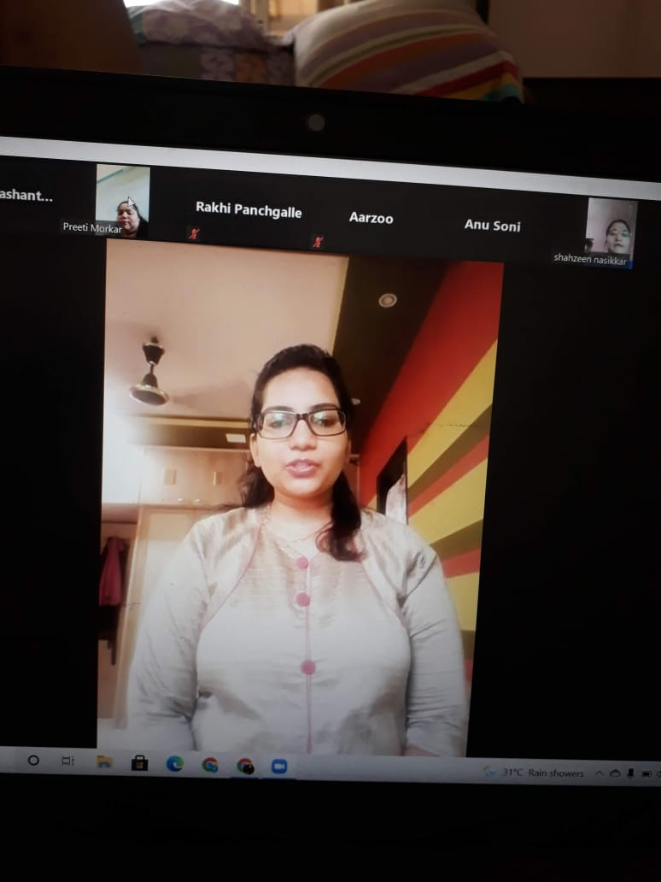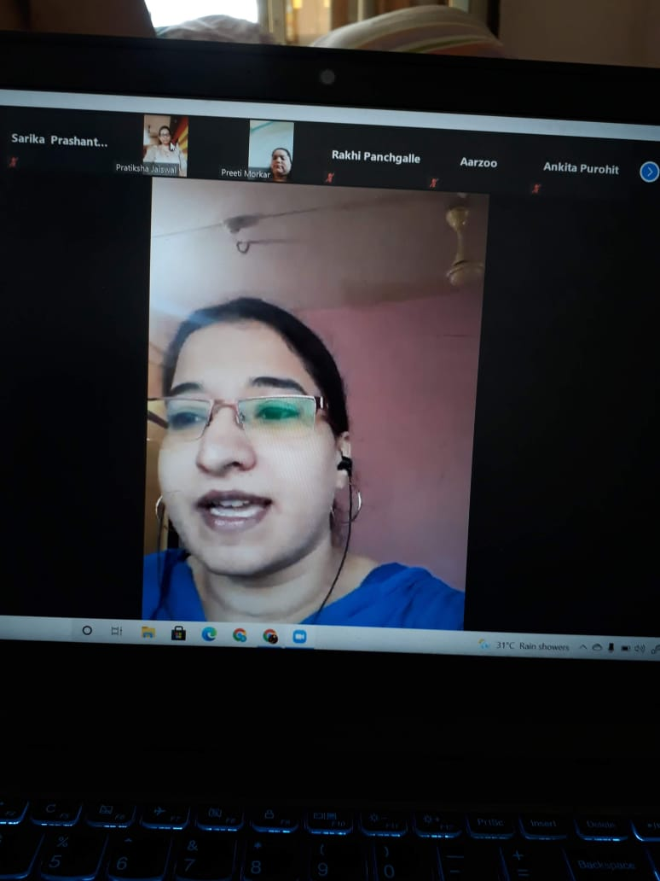

**Orientation programme**

Orientation programme provides the student teachers with concise and accurate information to make them more comfortable in their activities ; Encourages student’s confidence and helps the new students adapt faster to the course; Contributes to a more effective performance in all the activities; and Improves student’s retention.

The goal of the orientation programme is to equip the student with the necessary requirement of the activities in the teaching profession . To achieve these objectives our professors were guided our students at each and every step throughout the whole academic year of 1919-2020. Orientation was taken during the whole academy year through online mode for various activities such as skill development programme, for assignment writing, before starting the internship program etc.

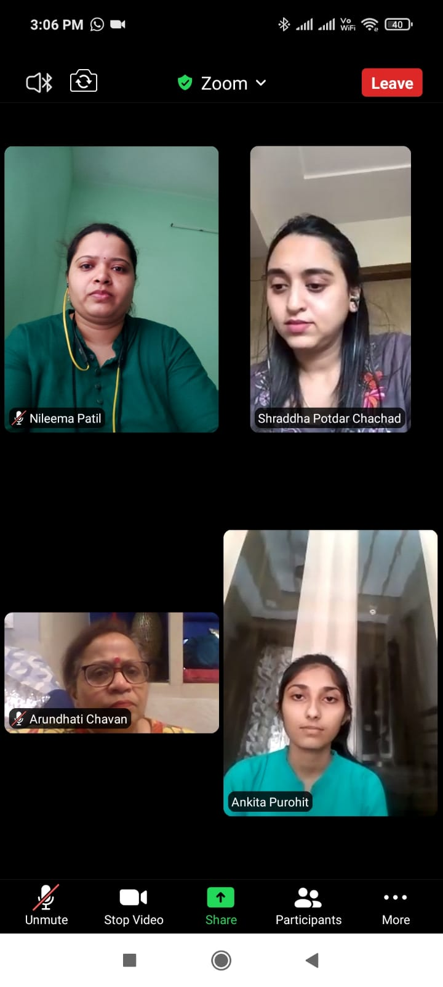

**Day celebration**

Different programmes where planed and organised by the college to inform the student teacher about the cultural importance of special days celebration in school,and also the importance of national integration. Student were participated in those activities. Following are the days which were celebrated during the year 2019-2020.

|  |  |
| --- | --- |
| **Days** | **Date** |
| Nanratri | 7 October |
| reading | 15 October |
| World student Day | 15 october |
| Eid Milad | 10 November |
| Diwali | 29 October |

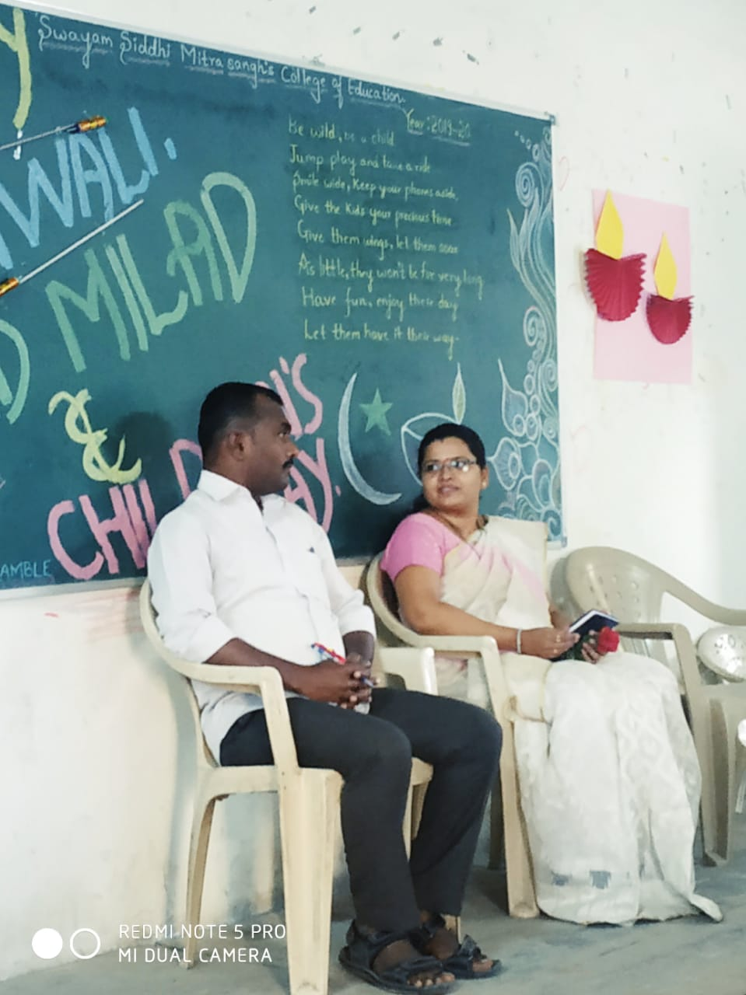 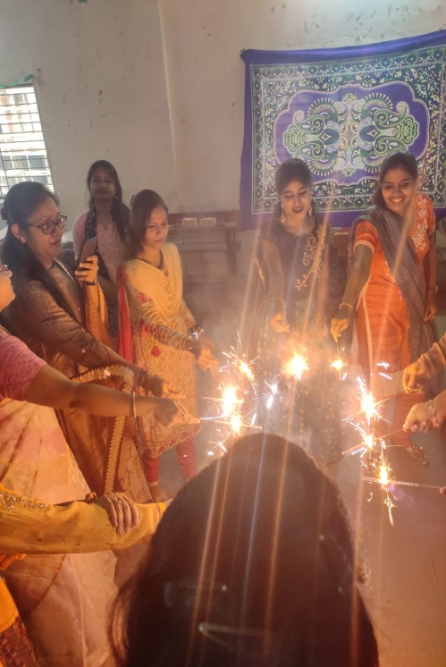

**TET Training**

In the year 2019-2020 Our H.O.D took orientation on TET Exam on 1 January 2020 . The aim of the training was to encourage students to appear in the TET exam and also to state impotence of TET exam . Orientation was done through power point presentation.

**CET Orientation**

To remove the anxieties of the students, a CET Orientation was planned towards the early part of April. However, as the pandemic spread and institutions closed down around mid March, uncertainty set in. When things settled down a bit, it was decided to conduct the CET orientation on 27 February 2019 in the online mode. Many participants attended the orientation.

**Community work**

**Visit to NGO**

NGO raises awareness about issues such as human rights ,violations environmental conservation, public health, poverty and more it is necessary for the B.Ed students to gain knowledge about those things. As it was covide year our students did this activity through online mode in that year.